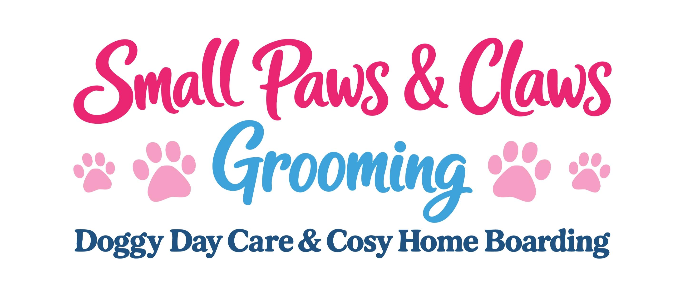
Day Care and Home Boarding Booking Form

STAY DETAILS

Register for regular bookings throughout the Years 2026/2027

Please ensure you sign and date, all three sections.

DOG 1 DETAILS

Name: Age: M/F
DOB
Neuter status: Last known heat if applicable:

Bread/Description:

Insurance details:

DOG 2 DETAILS

Name: Age: M/F
DOB
Neuter status: Last known heat if applicable:

Bread/Description:

Insurance details if applicable:

Please add additional dogs on a separate page.

How does your dog/s react with other dogs?

Is your dog/s allowed treats?

Can your dog/s be transported in my car?

OWNER DETAILS

Name:
__________________________________________________________________________________________

Address:
__________________________________________________________________________________________

Telephone number: Email address:

EMERGENCY CONTACT DETAILS

Name:
__________________________________________________________________________________________

Address:
__________________________________________________________________________________________

Telephone number: Email address:

VET DETAILS

Name: ____________________________________________________________________________________

Address: ___________________________________________________________________________________

Telephone number: Email address:

To the Veterinary Surgery: During my absence Small Paws will be caring for my dog(s) and has permission to transport them to your surgery for treatment. I authorise you to treat my dog(s) and I as the dog(s) owner will be responsible for payment to you not Small Paws.
I hereby give Small Paws permission to transport my dog to the above-mentioned veterinary surgeon, and make any decisions on treatments they feel need to be carried out without my permission. I understand that Small Paws assumes no responsibility for the loss of the dog(s) and is released from all liability related to transportation, treatment and expense. I, the dog owner, will pay for this.
Name
Date
Signature

MEDICAL DETAILS

Medical history:
__________________________________________________________________________________________

Current medical treatment:
__________________________________________________________________________________________

Vaccination record: Please provide a photocopy or WhatsApp me for my records, thank you.

Date of last worm and flea treatment:
__________________________________________________________________________________________

Diet/Feeding arrangements (Any food supplied from Small Paws will be at a cost of £2.00 per day, per dog):
__________________________________________________________________________________________
__________________________________________________________________________________________

Do you require our Wash and Blow dry service, £35.00 per dog: Yes No

Any additional Information:
___________________________________________________________________________
___________________________________________________________________________
___________________________________________________________________________

OWNER WRITTEN CONSENT: By signing this form, you as the owner are providing written consent to the licence holder implementing the exercise/enrichment/diet/feeding/sleeping requirements as detailed above.
In addition, you are also consenting to the following (please ask if you require additional details):

- Dog’s will/may be boarded with other dogs.
- The premises have a designated room for each boarded dog should it be necessary to separate them.
- Dog’s from the same household will be kept together at all times unless detailed otherwise.
- Unless detailed above dogs will be separated for feeding.
- Dog’s will/may be exercised on and off premises with other dogs.
- Dog’s will not be let off the lead unless we have been told that we can do.
- The licence holder will not be held responsible for injury, death or escape of a dog. In the event of injury or death, your dog will be taken to a veterinary practice until your return at the cost of the owner. In the event of an escaped dog, every effort will be made to find and return your dog.
- Medical treatment will be administered on the advice of a vet. Contact will be made with the owner/emergency contact where possible prior to treatment.
- In the case of a fire/other emergency the licence holder will house your dog in emergency accommodation.
- In the event of an illness your dog will be given veterinary treatment at the cost to the owner.
- In the event that your dog has fleas/ticks or worms your dog will be treated at a cost to the owner of £25.00 per treatment.
- The owner will be responsible for any damage to our property caused by the dog.

Name:
Date:
Signature:

Small Paws – Terms and Conditions
Payment Terms: All fees are payable on arrival by cash or bank transfer. Day rates are per day including the arrival and departure day.
Insurance: Owners must be responsible for having their own pet insurance. Any vets’ fees incurred for treatment of pre-existing conditions, must be settled by the owner at the time of collection. If your dog is taken to the vets, any outstanding veterinary fees must be settled prior to departure. Owners or your emergency contact will be contacted, if possible, prior to treatment given.

Vaccinations: All dogs must be fully vaccinated against Distemper, Hepatitis, Parvovirus, Para Influenza and Leptospirosis and must have had them within the last 12 months. Canine Infectious Bronchitis (also known as (Kennel Cough) is preferred and MUST be given at least 2 weeks before arrival.
Please note that there is still a chance that your dog can still contract Kennel Cough, even with having the vaccination, if you have any concerns then please take your dog to the vets.
Please ensure that your dog has recently been treated for fleas and worms. Your dog will be checked on arrival and if fleas are present, it will be treated straight away, and you will be charged £25.00. If worms are present in their stools, then they will be treated, and you will be charged £20.00.

Housing Dogs: By signing this document, you are authorising that your dog will be accommodated within our home, and will be interacting with other dogs.

Aggression: If your dog shows signs of aggression, contact will be limited for the safety of both the humans and other animals in the home. It maybe that we will have to crate your dog. All procedures will continue as normal and if possible, we will still walk your dog, singularly.

Contact: We will only contact you if your dog is not eating, falls ill or in the event your dog escapes. We are happy to reply to requests for updates on your dog’s stay. If your dog requires urgent veterinary treatment, we will isolate the dog and call either the owner or the emergency contact for consent, if either are not available we will decide what is in the dog’s best interest and take to the vets without consent.

Abandoned Animals: In the event of a dog not being collected the local authorities will be contacted, this may result in legal action being taken against you.

Dogs Belongings: We ask that you do not bring with you any bedding, Small Paws will provide all bedding and toys for their stay, however if you would like to bring something small which carries your scent then please do, please make sure that it is easily washable in case it gets soiled.

Peak Periods: The peak periods are Easter, summer holidays & Christmas/New Year. Our rates stay the same throughout the year except for Christmas/New Year and these can be found on our website.

Opening Hours, Drop Off, Collection and Doggy Test Days: Due to this being a business within our home, the opening hours are restricted to allow for privacy to the family members, the times also allow me to settle the new dogs into our home.

Monday to Saturday 9.30am – 5.30pm.

ID Tags: As part of the new Animal Welfare Regulations 2018, all dogs will be fitted with a identity tag on its collar. If your dog does not have a collar, one will be provided for their stay.

Dog Walking: Your dog will be walked at least twice a day for a minimum of 20 minutes unless you request less. Your dog will always be walked on a lead provided by yourselves. Small Paws and its staff will not accept liability for any incidents, accidents, or escapes.

Dog Washing & Blow Dry: We offer a dog bath and blow dry for £35.00; we walk your dogs whatever the weather so if you would like your dogs washed then this will be carried out on the day of departure or prior day when possible.

The laws of England and Wales govern these terms and conditions. Only sign this agreement if you intend to be bound by these terms and conditions. For and on behalf of Small Paws.

Name
Date
Signature
Small Paws – Check List
Small Paws, The Cleeve, Meriden Road, Fillongley, CV7 8DP Contact Danielle 07837532155 Email: dheavens@hotmail.co.uk Website: www.smallpaws-homedogboarding.co.uk
Please use this checklist to make sure you are prepared for your dogs’ arrival with us. By filling in the forms and signing the terms and conditions now, will make the drop off process more time friendly and ensuring that you have checked all that you need to bring will also avoid the possibility of us having to refuse your dog.

Drop off, Collection and Doggy Test Days: Monday to Saturday 9.3am to 5.30pm.

Please leave your dog in the car (leaving your window ajar) whilst we deal with the paperwork if required. I now collect and return your dogs via my car park as I have found it causes less disruption to the dogs that I have staying with me.

1, No vaccinations, No admission. No Dog will be checked in without their up-to-date vaccination card and a record of the kennel cough vaccination that has been given at least two weeks prior to arrival.
2, Please email or bring with you this filled out Booking Form and the signed Terms and Conditions.
3, Full payment must be received on arrival by cash or bank transfer.
4, Dog Food. Please remember to bring their own dog food for the duration of their stay; if we need to provide their food it is £2.00 per day, per dog.
5, Belongings. Only a small item that carries your scent is welcome.
6, Wash & Blow Dry. If you would like to have your dog washed and blow-dried, please remember to add this too your payment on arrival and provide shampoos and conditioners if your dog has allergies.

